**Join Our Team at Soft!**

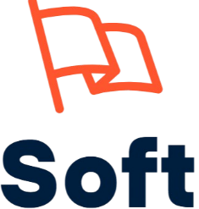

Hey dear Sir/Miss,

I hope this message finds you well! I’m reaching out because I think you’d be a fantastic addition to our team at **Soft**. We’re a group of passionate developers and creatives who work together on exciting projects, and I believe your skills and personality would fit right in.

**What We Do at Soft:**

At Soft, we’re all about **turning ideas into reality**. Whether it’s crafting sleek websites, building powerful software, or helping businesses navigate the tech landscape, we tackle a wide range of projects that challenge us to innovate and grow. From creating user-friendly apps to delivering polished presentations and reports, we’re always pushing the boundaries of what’s possible. Plus, we love diving into the latest tech trends and offering smart, practical solutions to our clients.

**Why Join Soft?**

At Soft, you’ll enjoy **flexibility to balance work with other commitments**, connect with a **diverse network of developers**, earn **extra income** based on your contributions, and gain access to **future perks and opportunities** as part of our growing team.

**What We’re About**

At Soft, we’re all about **collaboration, respect, and continuous improvement**. We treat each other like family, and we’re always looking for ways to support each other’s growth. It’s a fun, supportive, and rewarding environment to be part of.

If this sounds like something you’d be interested in, I’d love to chat more about it! Let me know if you’re up for a quick call or meeting to discuss how you can fit into the team.

Looking forward to hearing from you!

Cheers,

**NIKIEMA Abdoul Razack**



**Management Team Representative**

**Soft Team.**